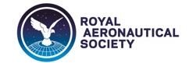
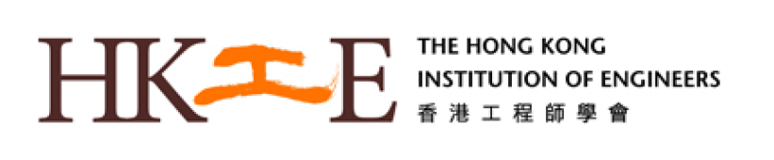

Technical Seminar

Structural Integrity, Reliability and Safety of
Gas Turbine Engines

Professor Herman Shen
Ohio State University; HKUST
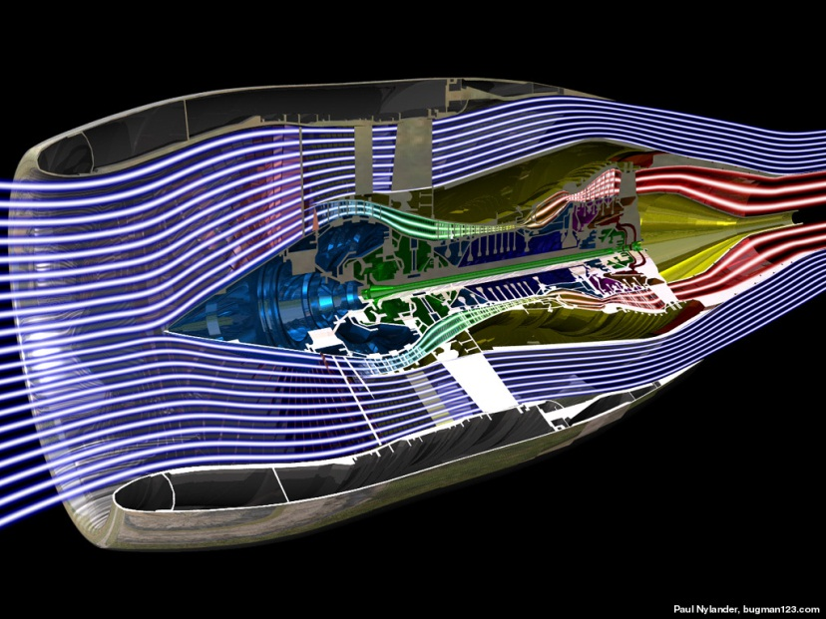
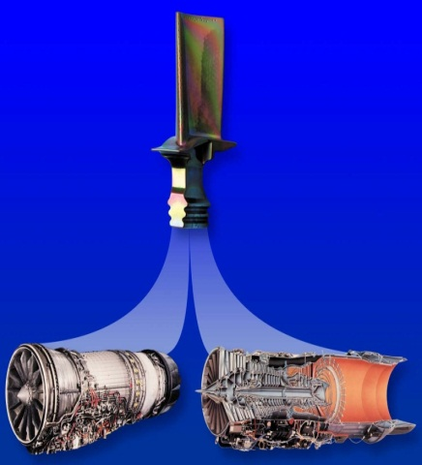
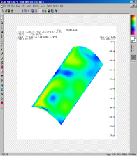
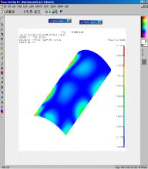
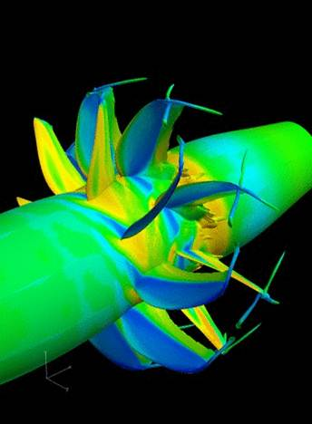
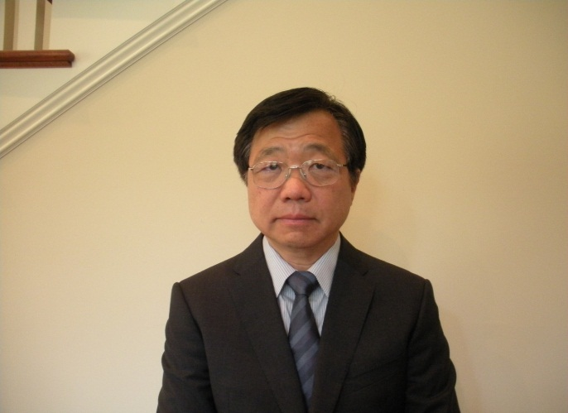

23 July 2014 (Wednesday) - 18:30pm
LTJ Theatre,
The Hong Kong University of Science and Technology,
Clearwater Bay

Open to all HKIE Members and Non-Members
Pre-registration (for CPD certificate) can be done using the link:
https://docs.google.com/forms/d/10VjvNipLWJppdunPX7omRL_php-1s6wZjv4gXP1ClVE/viewform

